# Sensor name:

# Smoke sensor

**Smoke sensor use:**

A smoke sensor is a sensor that senses smoke, typically as an indicator of fire. Commercial security devices issue a signal to a fire alarm control panel as part of a fire alarm system, while household smoke detectors, also known as smoke alarms, generally issue a local audible or visual alarm from the detector itself or several detectors if there are multiple smoke detectors interlinked.

**Digram:**

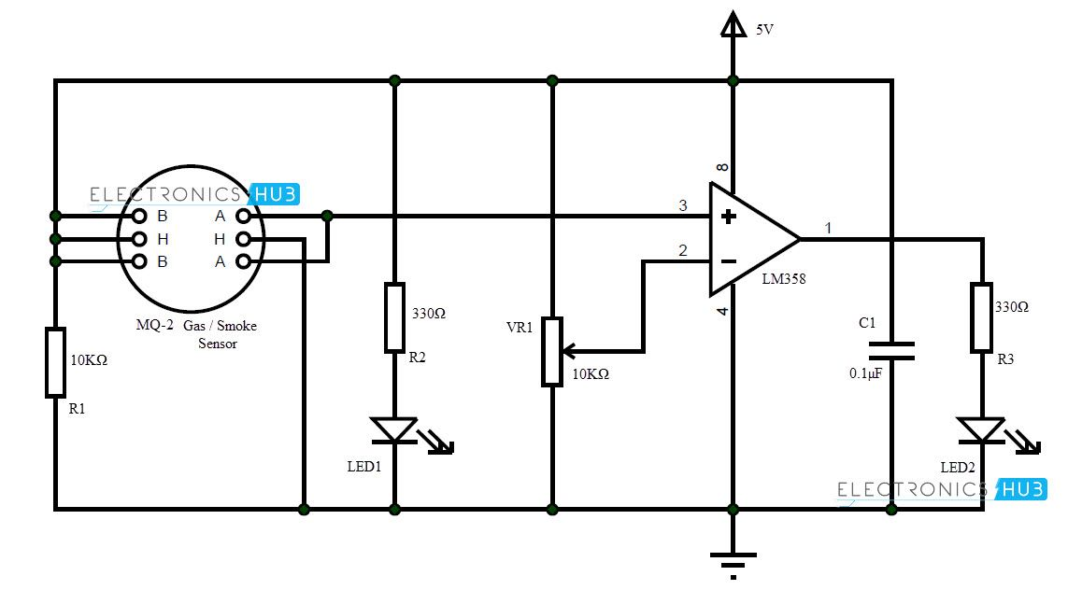

**Sensor From:**

Future electronics

[https://store.fut-electronics.com](https://store.fut-electronics.com/)

**sensor code:**

int redLed = 12;

int greenLed = 11;

int buzzer = 10;

int smokeA0 = A5;

// Your threshold value

int sensorThres = 400;

void setup() {

pinMode(redLed, OUTPUT);

pinMode(greenLed, OUTPUT);

pinMode(buzzer, OUTPUT);

pinMode(smokeA0, INPUT);

Serial.begin(9600);

}

void loop() {

int analogSensor = analogRead(smokeA0);

Serial.print("Pin A0: ");

Serial.println(analogSensor);

// Checks if it has reached the threshold value

if (analogSensor > sensorThres)

{

digitalWrite(redLed, HIGH);

digitalWrite(greenLed, LOW);

tone(buzzer, 1000, 200);

}

else

{

digitalWrite(redLed, LOW);

digitalWrite(greenLed, HIGH);

noTone(buzzer);

}

delay(100);

}

**Guide Link:**

https://www.hackster.io/Aritro